BUYER'S GUIDE

BUYERS GUIDE

STAGE OF PURCHASING A PROPERTY

- Administrative
-Obtaining the NIE
Every foreign resident who wishes to carry out a real estate transaction in Spain must be in possession of a NIE (Foreign Identification Number). Serving as identification before the Spanish State, it is also necessary for operations such as the purchase of a vehicle, the opening of a bank account, or the contracting of services such as the supply of electricity, water, gas, internet, etc.
-Open a bank account in Spain
Yes, opening a bank account is essential to buy property in Spain.
- Search property with your agent
Our agency will be at your disposal to find you the best property that meets the criteria you want. The agent will plan visits to the different properties offered, in order to find the one that best suits you.
Throughout the property search process, we will advise you as best as possible and tell you the negative and positive points of each property, in order to better guide you in your search.
- negotiation
Once the property is found, we will pass the offer to the seller and negotiate the conditions of sale of the property. Our Agent will advise you on the offer to make to be sure of being able to purchase the property.
Once the offer is accepted, we will formalize the reservation contract to take the property off the market and establish the dates of the deposit contract (10%) and the definitive purchase and sale contract.
- Definitive signature
We will accompany you to the signing of the sale before a notary, and until the delivery of the keys to your new property.

Marbella Place has created especially for its clients the buyer's guide to download, in order to have all the important information for the purchase of their home, and also the costs generated by the purchase of a home.

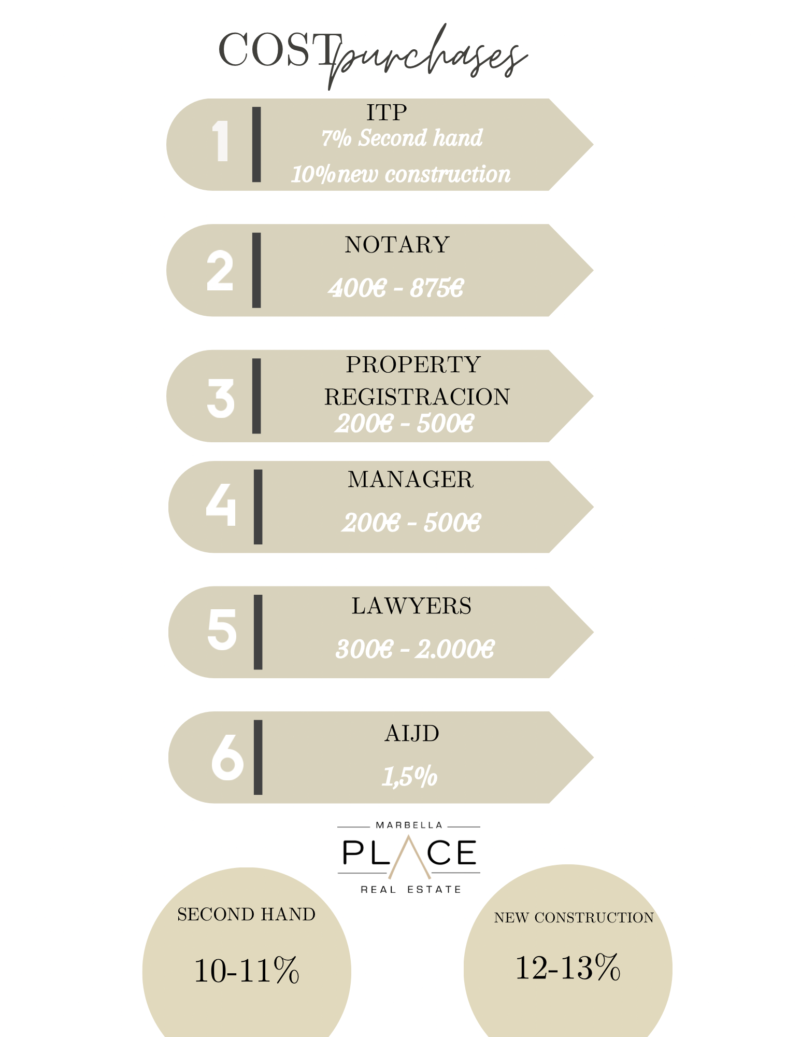
PURCHASE-SALE COST

